DAY-9
1.write a C program for binary tree.
#include <stdio.h>
#include <stdlib.h>
struct Node {
int data;
struct Node* left;
struct Node* right;
};
struct Node* createNode(int data) {
struct Node* newNode = (struct Node*)malloc(sizeof(struct Node));
newNode->data = data;
newNode->left = newNode->right = NULL;
return newNode;
}
void preorderTraversal(struct Node* root) {
if (root == NULL) return;
printf("%d ", root->data);
preorderTraversal(root->left);
preorderTraversal(root->right);
}
void inorderTraversal(struct Node* root) {
if (root == NULL) return;
inorderTraversal(root->left);
printf("%d ", root->data);
inorderTraversal(root->right);
}
void postorderTraversal(struct Node* root) {
if (root == NULL) return;
postorderTraversal(root->left);
postorderTraversal(root->right);
printf("%d ", root->data);
}
int main() {
struct Node* root = createNode(1);
root->left = createNode(2);
root->right = createNode(3);
root->left->left = createNode(4);
root->left->right = createNode(5);
printf("Preorder traversal: ");
preorderTraversal(root);
printf("\nInorder traversal: ");
inorderTraversal(root);
printf("\nPostorder traversal: ");
postorderTraversal(root);
return 0;
}
OUTPUT:
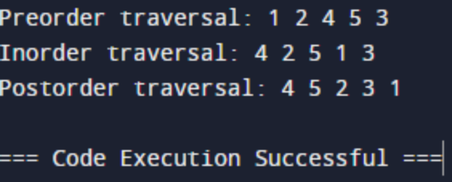

2.write a C program for binary search tree.
#include <stdio.h>
#include <stdlib.h>
struct Node {
int data;
struct Node *left;
struct Node *right;
};
struct Node* createNode(int value) {
struct Node* newNode = (struct Node*)malloc(sizeof(struct Node));
newNode->data = value;
newNode->left = NULL;
newNode->right = NULL;
return newNode;
}
struct Node* insertNode(struct Node* root, int value) {
if (root == NULL) {
return createNode(value);
}
if (value < root->data) {
root->left = insertNode(root->left, value);
} else if (value > root->data) {
root->right = insertNode(root->right, value);
}
return root;
}
struct Node* searchNode(struct Node* root, int value) {
if (root == NULL || root->data == value) {
return root;
}
if (value < root->data) {
return searchNode(root->left, value);
}
return searchNode(root->right, value);
}
struct Node* minValueNode(struct Node* node) {
struct Node* current = node;
while (current && current->left != NULL) {
current = current->left;
}
return current;
}
struct Node* deleteNode(struct Node* root, int value) {
if (root == NULL) {
return root;
}
if (value < root->data) {
root->left = deleteNode(root->left, value);
} else if (value > root->data) {
root->right = deleteNode(root->right, value);
} else {
if (root->left == NULL) {
struct Node* temp = root->right;
free(root);
return temp;
} else if (root->right == NULL) {
struct Node* temp = root->left;
free(root);
return temp;
}
struct Node* temp = minValueNode(root->right);
root->data = temp->data;
root->right = deleteNode(root->right, temp->data);
}
return root;
}
int main() {
struct Node* root = NULL;
root = insertNode(root, 50);
insertNode(root, 30);
insertNode(root, 20);
insertNode(root, 40);
insertNode(root, 70);
insertNode(root, 60);
insertNode(root, 80);
int searchValue = 40;
struct Node* searchResult = searchNode(root, searchValue);
if (searchResult != NULL) {
printf("%d found in the tree.\n", searchValue);
} else {
printf("%d not found in the tree.\n", searchValue);
}
int deleteValue = 30;
root = deleteNode(root, deleteValue);
return 0;
}
OUTPUT:
